The Relational Database Model

Relational model concepts
The relational Model of Data is based on the concept of a Relation
- The strength of the relational approach to data management comes from the formal foundation provided by the theory of relations.
- We review the essentials of the formal relational model
- In practice, there is a standard model based on SQL.
- Note: There are several important differences between the formal model and the practical model.

Informal definitions
- Informally, a relation looks like a table of values.
- A relation typically contains a set of rows.
- The data elements in each row represent certain facts that correspond to a real-word entity or relationship
  - In the formal model, rows are called tuples.
- Each column has a column header that gives an indication of the meaning of the data items in that column
  - In the formal model, the column header is called an attribute name (or just attribute).
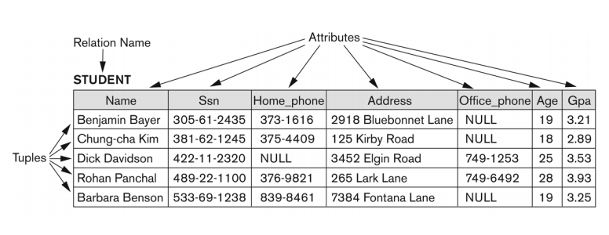

- Key of a Relation:
  - Each row has a value of a data item (or set of items) that uniquely identifies that row in the table, called the key.
- In the STUDENT table, SSN is the key.
- Sometimes row-ids or sequential numbers are assigned as keys to identify the rows in a table, called the artificial key or surrogate key.

Formal definitions

Schema
- The Schema (or description) of a Relation:
  - Denoted by R(A1, A2, …, An)
  - R is the name of the relation
  - The attributes of the relation are A1, A2, …,An
- e.g.:
CUSTOMER (Cust-id, Cust-name, Address, Phone#)
  - CUSTOMER is the relation name
  - Defined over the four attributes.
- Each attribute has a domain or a set of valid values.
  - For example, the domain Cust-id is 6 digit numbers.

Tuple
- A tuple is an ordered set of values (enclosed in angled brackets ‘< … >’)
- Each value is derived from an appropriate domain.
- A row in the CUSTOMER relation is a 4-tuple and would consist of four values, for example:
  - <632895, “John Smith”, “101 Main St. Atlanta, GA 30332”, “(404) 894-2000”>
  - This is a 4-tuple as it has 4 values
  - A tuple (row) in the CUSTOMER relation.
- A relation is a set of such tuples (rows).

Domain
- A domain (a set of atomic values) has a logical definition:
  - USA_Phone_numbers are the set of 10 digit phone numbers valid in the U.S.
- It can also have a format defined for it, e.g.: the date (yyyy-mm-dd), U.S. phone numbers (ddd)ddd-dddd.
- The attribute name designates the role played by a domain in a relation:
  - Used to interpret the meaning of the data elements corresponding to that attribute.
    - The domain Date may be used to define two attributes named “Invoice-date” and “Payment-date” with different meanings.

State
- The relation state is a subset of the Cartesian product of the domains of its attributes.
  - i.e. each domain contains the set of all possible values the attribute can take.
- Example: attribute Cust-name is defined over the domain of character strigns of maximum length 25
  - dom(Cust-name) is varchar(25)
- The role these strings play in the CUSTOMER relation is that of the name of a customer.

Relation characteristics
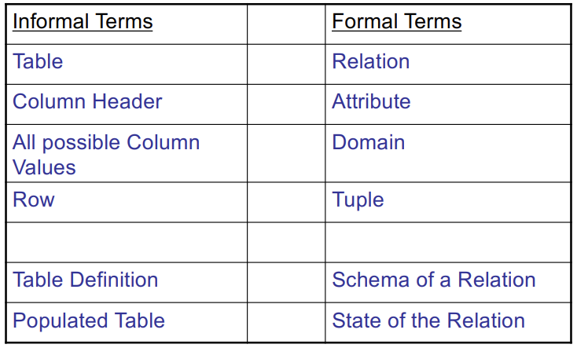

Characteristics of relations
- Relation is a set of tuples.
- Ordering of tuples in a relation r®:
  - The tuples are not considered to be ordered, even though they appear to be in the tabular form.
- Ordering of attributes in a relation schema R (and of values within each tuple):
  - We will consider the attributes in R(A1, A2, …, An) and the values in t=<v1 v2, …, vn> to be ordered.
    - (However, a more general alternative definition of relation does not require this ordering)
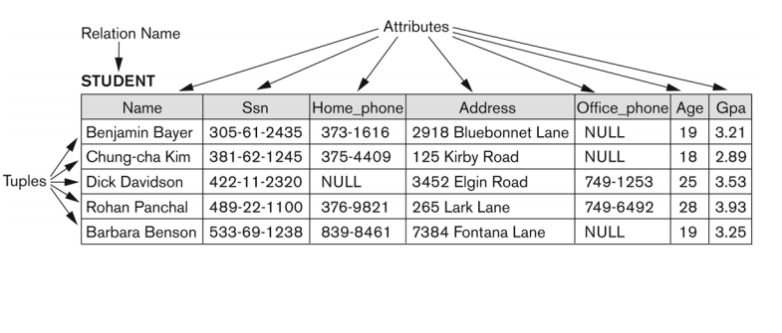
We have the same state, but with a different order of Tuples.

Characteristics of relations
- Values in a tuple:
  - All values are considered atomic (indivisible).
  - Each value in a tuple must be from the domain of the attribute for that column
    - If tuple t = <v1, v2, …, vn> is a tuple in the relation state r of R(A1, A2, …, An), then each vi must be a value from dom(Ai).
- A special null value is used to represent values that are unknown or inapplicable to certain tuples.
- Notation:
  - We refer to component values of a tuple t by:
    - t[Ai] or t.Ai
    - This is the value vi of attribute Ai for tuple t.
  - Similarly, t[Au, Av, …, Aw] refers to the subtuple of t containing the values of attributes Au, AV, …, Aw, respectively in t.

Relational integrity constraints
Constraints are conditions that must hold on all valid relation states.
- There are three main types of constraints in the relational model:
  - Key constraints
  - Entity integrity constraints
  - Referential integrity constraints
- Another implicit constraint is the domain constraint
  - Every value in a tuple must be from the domain of its attribute (or it could be null, if allowed for that attribute).

Key Constraints
- Superkey of R
  - Is a set of attributes SK of R with the following condition:
    - No two tuples in any valid relation state r(R) will have the same value for SK
    - That is, for any distinct tuples t1 and t2 in r®, t1[SK] =/= t2[SK]
    - This condition must hold in any valid state r®
- Key of R
  - A “minimal” superkey
  - That is, a key is a superkey K such that removal of any attribute from K results in a set of attributes that is not a superkey (does not possess the superkey uniqueness property).
Consider the CAR relation schema:
- CAR(State, Reg#, SerialNo, Make, Model, Year)
CAR has two keys:
Key1 = {State, Reg#}
Key2 = {SerialNo}
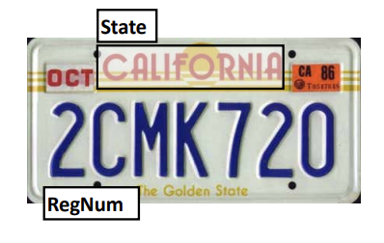
- Both are also superkeys of CAR
- {SerialNo, Make} is a superkey but not a key.
In general:
- Any key is a superkey (but not vice versa)
- Any set of attributes that includes a key is a superkey
- A minimal superkey is also a key.
If a relation has several candidate keys, one is chosen arbitrarily to be the primary key.
- The primary key attributes are underlined.
  - e.g. in the CAR relation schema, CAR(State, Reg#, SerialNo, Make, Model, Year)
- The primary key value is used to uniquely identify each tuple in a relation
  - Provides the tuple identity
- Also used to reference the tuple from another tuple
  - General rule: Choose as primary key the smallest of the candidate keys (in terms of size)
  - (not always applicable)
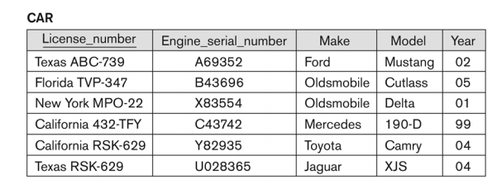

Foreign keys
Consider the COMPANY database schema:
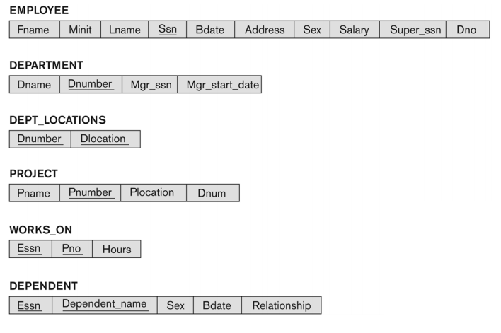

Entity integrity
- The primary key attributes PK of each relation schema R in S cannot have null values in any tuple of r(R)
  - i.e. t[PK] =/= null
  - if PK has several attributes, null is not allowed in any of these attributes.
- Note: other attributes of R may be constrained to disallow null values, even though they may not be members of the primary key.

Referential integrity
- A constraint involving two relations
  - The previous constraints involve a single relation.
- Used to specify a relationship among tuples in two relations:
  - The referencing relation and the referenced relation.

Foreign key
A set of attributes FK in relation schema R1 is a foreign key of R1 that references relation R2 if it satisfies the following two rules:
- The attributes in FK have the same domain(s) as the primary key attributes PK or R2
  - The attributes FK are said to reference or refer to the relation R2
- A value of FK in tuple t1 or r1(R1) either occurs as a value of PK for some tuple t2 in the relation state r2(R2) or it is null.
  - t1[FK] = t2[PK], i.e. tuple t1 references or refers to tuple t2.
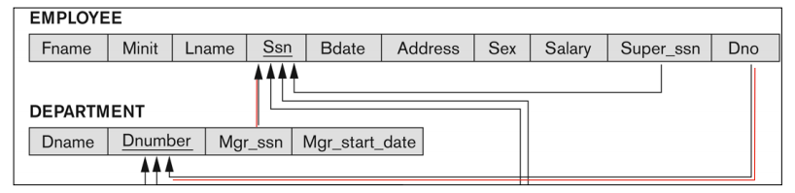

Referential integrity
Tuples in the referencing relation R1 have attributes FK (called foreign key attributes) that reference the primary key attributes PK of the referenced relation R2.
- A tuple t1 in R1 is said to reference a tuple t2 in R2 if t1[FK] = t2[PK].
A referential integrity constraint can be displayed in a relational database schema as a directed arc from R1.FK to R2.PK

Referential integrity Constraint
- Statement of the constraint
  - The value in the foreign key column (or columns) FK of the referencing relation R1 can be either:
    - (1) A value of an existing priamry key value of a corresponding primary key PK in a referenced relation R2, or
    - (2) a null.
  - In case (2), the FK in R1 should not be a part of its own primary key.

Displaying a relational database schema and its constraints
Each relation schema can be displayed as a row of attribute names
- The name of the relation is written above the attribute names.
- The primary key attribute (or attributes) will be underlined.
- A foreign key (referential integrity) constraints is displayed as a directed arc (arrow) from the foreign key attributes to the referenced table
  - Can also point to the primary key of the referenced relation for clarity
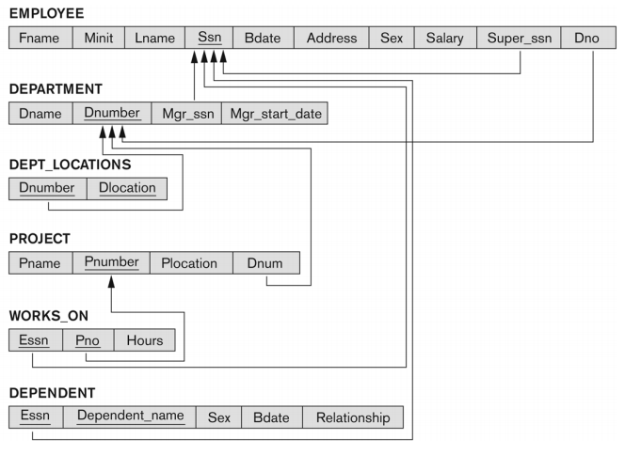

Other types of constraints
Semantic Integrity Constraints:
- Based on application semantics and cannot be expressed by the model per se.
- Example: “the max. no. Of hours per employee for al projects he/she works on is 56 hours per week”
  - A constraint specification language may have to be used to express this.
    - SQL-99 allows triggers and ASSERTIONS to express some of these constraints.
- Another example: “Employees cannot be aged under 16”

Operations on relations

Populated database state
- Each relation will have many tuples in its current relation state.
- The relational database state is a union of all the individual relation states.
- Whenever the database is changed, a new state arises.
- Basic operations for changing the database:
  - INSERT a new tuple in a relation
  - DELETE an existing tuple from a relation
  - MODIFY an attribute of an existing tuple
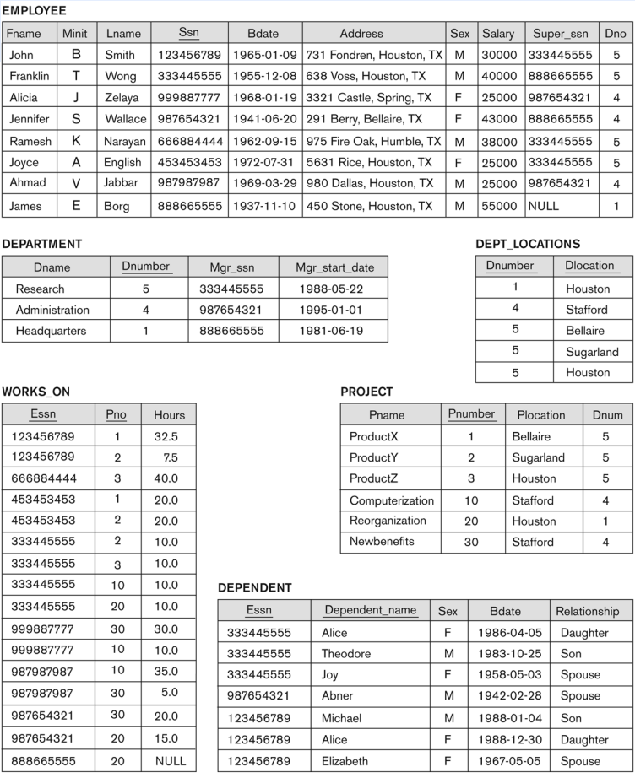

Update operations on relations
- Integrity constraints should not be violated by the update operations.
- Several update operations may have to be grouped together
- Updates may propagate to cause other updates automatically. This may be necessary to maintain integrity constraints.
In case of integrity violation, several actions can be taken:
- Cancel the operation that causes the violation (RESTRICT or REJECT)
- Perform the operation but inform the user of the violation
- Trigger additional updates so the violation is corrected (CASCADE option, SET NULL option)
- Execute a user-specified error-correction routine.

Possible violations for each operation
INSERT may violate any of the constraints:
- Domain constraint
  - If one of the attribute values for the new tuple is not of the specified attribute domain.
- Key constraint
  - If the value of a key attribute in the new tuple already exists in another tuple in the relation
- Referential integrity:
  - If a foreign key value in the new tuple references a primary key value that does not exist in the referenced relation
- Entity integrity
  - If the primary key value is null in the new tuple.

DELETE may violate referential integrity:
- If the primary key value of the tuple being deleted is referenced from other tuples in the database
  - Can be remedied by several actions: RESTRICT, CASCADE, SET NULL
    - RESTRICT: Reject deletion, CASCADE: delete referencing tuples, SET NULL: set the foreign keys of the referencing tuples to NULL
  - One of the above options must be specified during database design for each foreign key constraint.

UPDATE may violate domain constraint and NOT NULL constraint on an attribute being modified
- Any of the other constraints may also be violated, depending on the attribute being updated:
  - Updating the PK:
    - Similar to a DELETE Followed by an INSERT
    - Need to specify similar options to DELETE
  - Updating a FK:
    - May violate referential integrity
  - Updating an ordinary attribute
    - Can only violate domain constraints.

